Time Management

Weekly Planning Sheet

Questions to consider when filling in your calendar:

- When are your major assignments due? When are exams and paper deadlines? (Best to review the academic calendar to get a sense for when assignments are clustered together and when you have stretches of free time.)
- What fuels you and brings you energy? (Are there enough of these types of activities in your calendar to sustain you? How can you budget time in order to increase opportunities for these types of activities and interactions?)
- Do you need to do something fun in order to be motivated to begin work or do you need to feel like you have earned a break after a certain amount of work? Schedule in your social/reward times according to your motivation style.
- Are you filling in meals and healthy blocks of time for sleep?
- How long can you reasonably focus for at a time? Build these time blocks into your schedule with regularly scheduled breaks.
- Are you building enough time into your schedule to reach out to faculty for clarification, to attend recitations and review sessions, or to visit the writing center for extra support?
- What has gone well in the first few months of school? What do you want to do differently moving ahead?
- Who around you can keep you accountable?
- How have you been procrastinating and how much time has procrastination taken up?
- What do you value? Are the activities you are choosing in support of those values?

Fill in the chart below:

Regularly scheduled events (classes, review sessions, practice, etc.)
Meals/Sleep/Physical Activity/Clubs/Activities
Deadlines
Assignments (estimate realistic time to complete)
Fun/Hanging Out
Cushion times - Things come up!

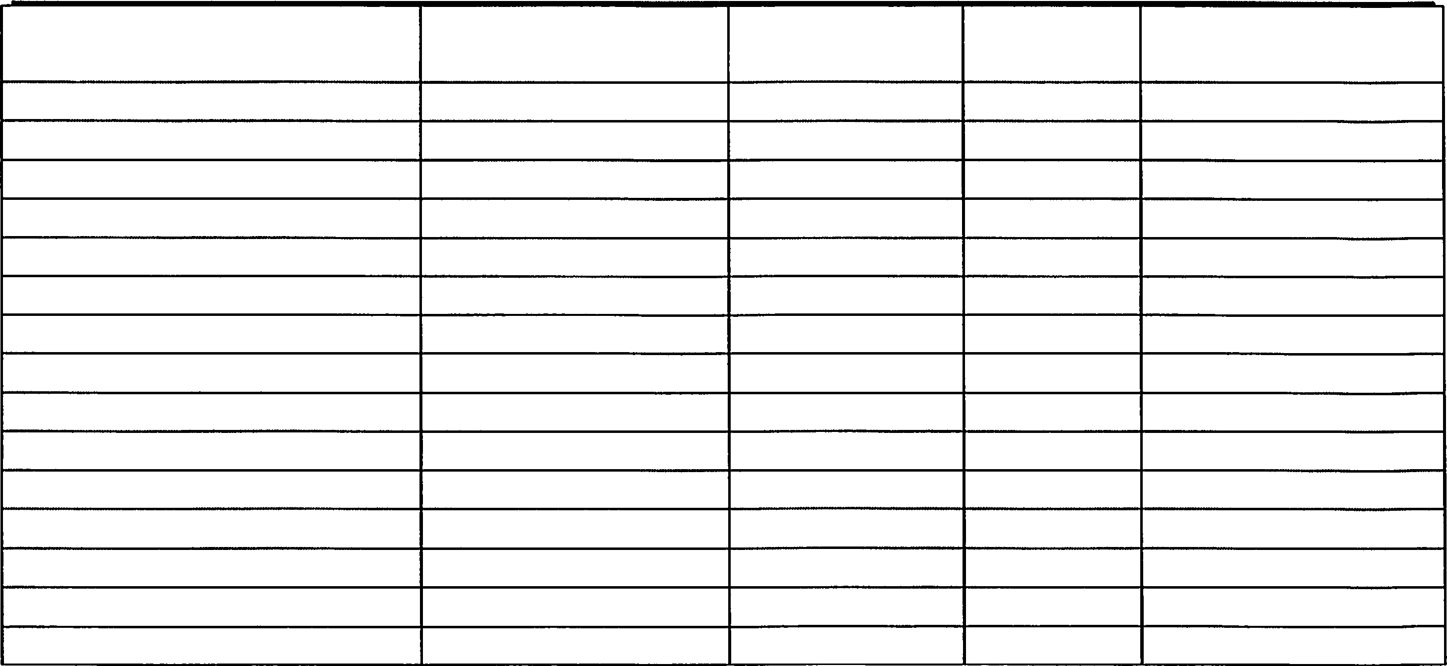
Assignment/l 'a<,k
Time Needed
Due date
P1i01ity
Resources Needed?
Plan ahead

Cited and adapted from Haverford College, link to Haverford College, Office of Academic Resources

