Task Time Tracker

- - -

I
Task Estimated

I
!
Start

..

. .
Finish (actual)

I
- - - -

I

-
i

I
-
Notes

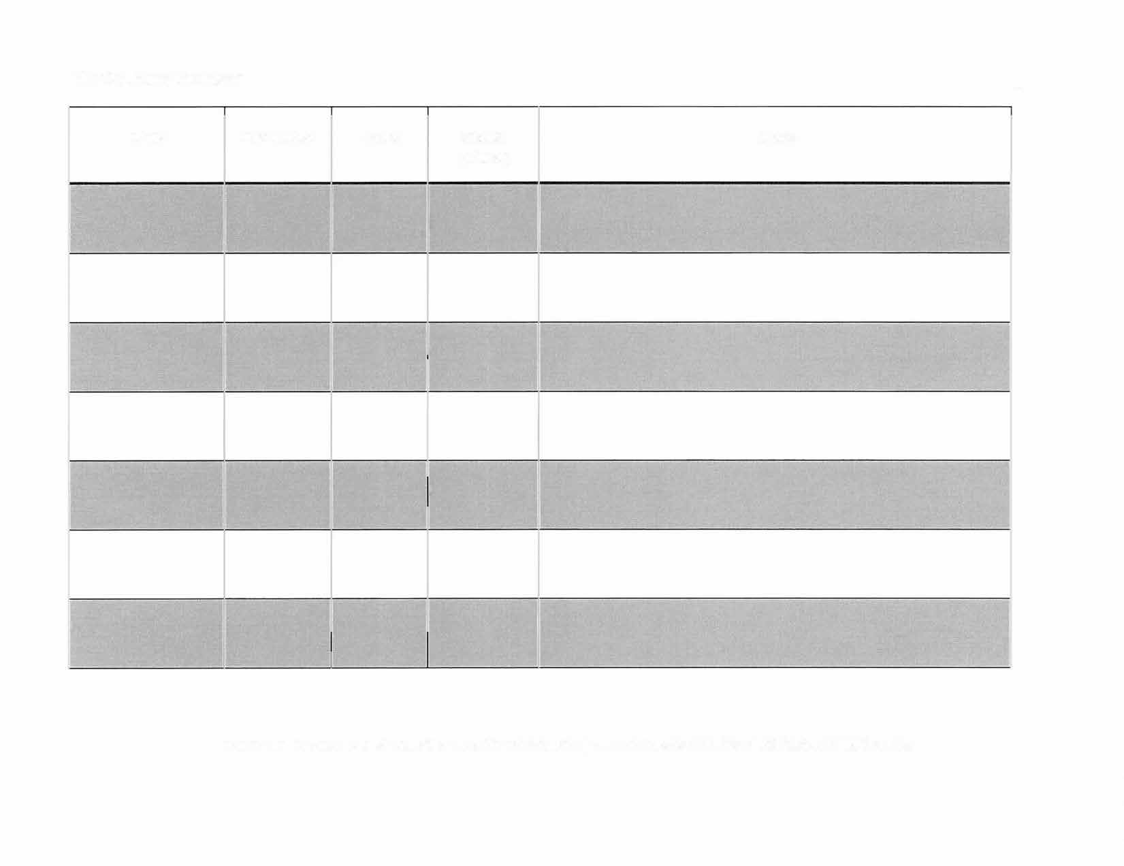
Cited and adapted from Haverford College, link to Haverford College, Office of Academic Resources

