Hybrid Republicanism:

Italy and American Art, 1840-1918

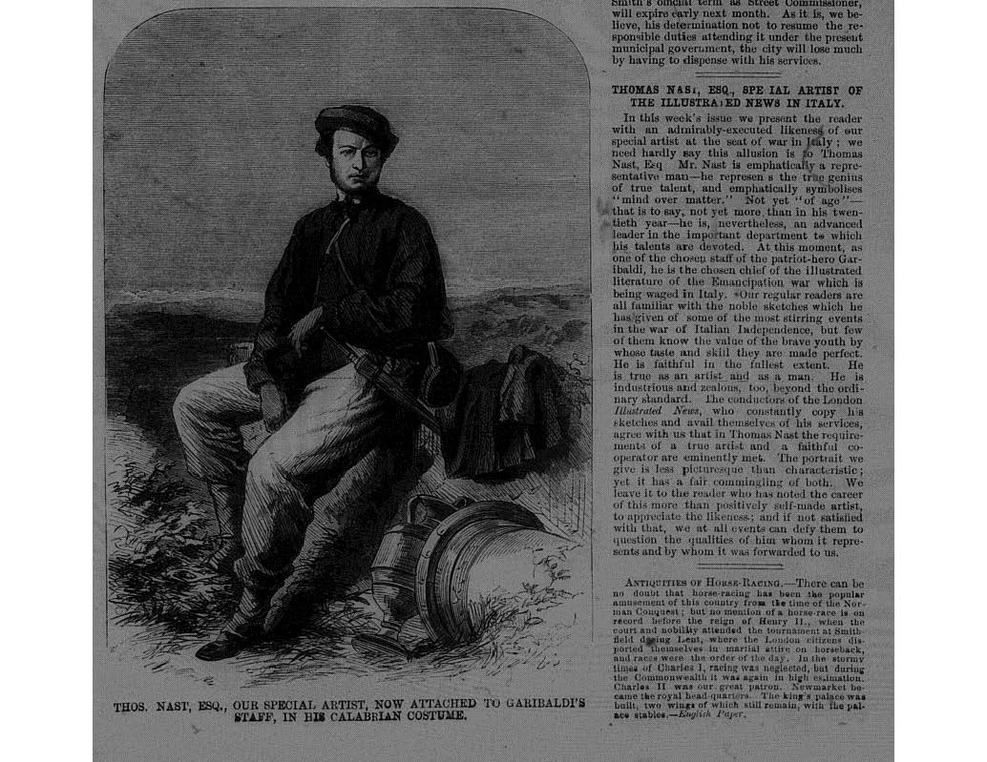
Hybrid Republicanism: Italy and American Art, 1840-1918 is an international conference that will consider the shared notions of republicanism and tyranny that animated American and Italian politics and visual culture in the nineteenth and early twentieth centuries. The program will take into account significant historical events that linked Italy and the United States, such as the Italian wars of independence, the American Civil War, the founding of the Italian nation with Rome as its capital, the rise and decline of progressive reform in Italy and the United States, and Italian and American participation in World War I. The event will take place on October 6-7, 2016 and is sponsored by the Terra Foundation for American Art, the American Academy in Rome, and the Centro Studi Americani, Rome with assistance from the Smithsonian American Art Museum, American Embassy in Rome, Università degli Studi Roma Tre, Università di Macerata, Purchase College, the State University of New York, and Kenyon College. A sister conference, “The Course of Empire: American Fascination with Classical and Renaissance Italy, 1760-1970,” will occur at the Smithsonian American Art Museum, Washington, DC on October 20-21, 2017.
New York Illustrated News, November 3, 1860

Keynote Address and Reception: October 6, 2016, 6:00pm-8:30pm at the Centro Studi Americani, Palazzo Mattei, Rome.

Don H. Doyle, McCausland Professor of History, University of South Carolina, and Director of ARENA, the Association for Research on Ethnicity and Nationalisms in America, “The Republican Experiment: America, Italy, and the Perils of Self-Government”

Conference Schedule: October 7, 2016, 9:30am-1:00pm, 2:30pm-6:00pm, at the American Academy in Rome, Via Angelo Masina 5, Rome.

All events are free and open to the public. For entry to the AAR, please show ID; no backpacks allowed.
Speakers:
Daniele Fiorentino, Professor of U. S. History, Department of Political Science, Università degli Studi Roma Tre and conference co-organizer, Welcome and Introductions

Leonardo Buonomo, Professor of American Literature, Department of Humanities, Università degli Studi di Trieste, “Past Glories, Present Miseries: Reading Italy through Art in Catharine Maria Sedgwick’s Letters from Abroad to Kindred at Home”

Melissa Dabakis, Professor and Chair of Art History, Kenyon College and conference co-organizer, “Thomas Nast, Garibaldi, and I Mille: The Making of an Icon in the American Press”

Paul Kaplan, Professor of Art History, Purchase College, State University of New York and conference co-organizer, “Monuments to Tyranny: Issues of Race and Power in Nineteenth-Century Responses to Italian Public Sculpture”

Adam M. Thomas, Curator of American Art, Palmer Museum of Art, Pennsylvania State University, “Racial Hybridity and National Prophecy in Elihu Vedder’s The Cumean Sibyl”

Adrienne Baxter Bell, Associate Professor of Art History, Marymount Manhattan College, “A Reluctant Revolutionary: Elihu Vedder in the Circle of the Macchiaioli”

Marina Camboni, Professor Emerita of American Literature and Honorary President, Center for Italian American Studies, Università di Macerata, “American Artists and Enrico Nencioni’s Role as Mediator, Interpreter, and Translator in the Second Half of the Nineteenth Century”

Maria Saveria Ruga, Lecturer, Accademia di Belle Arti di Catanzaro, “The Progress of America (1880) by Andrea Cefaly: Social Reform in Italy and the United States”

Lindsay Harris, Andrew W. Mellon Professor-in-Charge, School of Classical Studies, American Academy in Rome, “Capital ‘Wastelands’: Photography in Rome and Washington, DC at the Turn of the Twentieth Century”

Andrea Mariani, Professor Emeritus, Department of Modern Languages, Literatures and Cultures, Università G. D’Annunzio, Chieti-Pescara, “Statues in Rome: Political Allegories and Cultural Archetypes”

